

**BIONIC ENGINEERS**

Bengaluru, Karnataka, India

AN INTERNSHIP REPORT

ON

“Website for Quient Training Pvt Ltd”

#### Bachelor of Engineering

#### In

#### Information Science and Engineering

#### 

#### Submitted by: MOKSHA.S.BABU (1RR18CS078)

#### 

#### 

**COLLEGE-NAME(CHANGE YOUR LOGO)**

#### 2021

## ABOUT THE COMPANY

Quient training is an enthusiastic group intended to train students in colleges that are denied the privilege of Placement training, A group of Enthusiasts now have a vision of training students that don’t have access to placement training that can help them get placed, and thereby build their future.

Some of our services include:

Development - We develop responsive, functional and super-fast websites.

We keep User Experience in mind while creating websites. A website should load quickly and should be accessible even on a small view-port and slow internet connection.

Mobile Application - We offer a wide range of professional Android, iOS & Hybrid app development services for our global clients, from a start up to a large enterprise.

Design - We offer professional Graphic design, Brochure design & Logo design. We are experts in crafting visual content to convey the right message to the customers.

Consultancy - We are here to provide you with expert advice on your design and development requirement.

Pictures - We create a polished professional pictures that impresses your audience.

**i**

**TABLE OF CONTENTS**

About the company i

Table of contents ii

Overview of the Project 1

Tools Used 2

Implementation 3

Snapshots 31

Bibliography 36

ii

## OVERVIEW OF THE PROJECT

## Project Name: Quient Training to Bionic

**Team Members:** NAME 1- S Shanmukha Priya

**NAME 2- Roddam Sushmitha**

**NAME 3- Moksha.S.Babu**

**NAME 4- Kummara Venkata Tejaswini**

## This project is based on Web Development And its Applications. The main objective of this project is to learn the implementation of HTML, CSS and JavaScript. The basic webpage of this project is created using HTML and styling of the webpage is done using CSS.

## This webpage is about the Placement training

Placement training plays a major role in shaping up the career goals of students. It is the dream of every engineering student to get placed in a top organization visiting their campus for recruitment. Keeping this key aspect into consideration, it is realized that training is important for engineering students to enhance their employability skills and achieve good placement in various Industries At present, the competition for employment is increasing every day and placement has become a challenging task. Training students and equipping them with life skills has become an important responsibility of the institution. Along with technical expertise, the development of a holistic personality is also necessary

1

# TOOLS USED

### Software Requirements

* Visual Studio Code.
* Google Chrome or Microsoft Edge of latest version.
* Tools: HTML, CSS, JS .
* Window : CPU with UG(unrestricted guest) support.

### Hardware Requirements

* Pentium 200-MHz computer with a minimum of 64 MB of RAM (128 MB of RAM recommended).
* Monitor with a refresh rate of at least 40Hz for a smooth GUI experience (optional).
* Operating system : 64-bit Window 8 or 10/MacOS/Linux.

2

# IMPLEMENTATION

# Source Code (HTML):

# 1.Index.html

<!DOCTYPE html>

<html>

<head>

    <meta charset="utf-8">

    <meta name="viewport" content="width=device width,initial-

        scale=1.0">

    <title>Quient group Pvt Ltd</title>

    <link rel="stylesheet" href="mstyle.css">

    <link rel="stylesheet" href="assest/css/preloader.css">

    <script src="https://kit.fontawesome.com/e4d122ab4a.js" crossorigin="anonymous"></script>

</head>

<body>

    <section class="header">

        <nav>

            <a href="index.html"><img src="https://tse1.mm.bing.net/th?id=OIP.Gq7py3P30GQQQSv75DLwrAHaEc&pid=Api&P=0&w=297&h=179.jpg"></a>

            <div class="nav-links" id="navLinks">

                <i class="fa fa-times" onclick="hideMenu()"></i>

                <ul>

                    <li><a href="index.html">HOME</a></li>

                    <li><a href="objectives.html">ABOUT</a></li>

                    <li><a href="Training Activities.html">TRAINING ACTIVITIES</a></li>

                    <li><a href="contact.html">CONTACT</a></li>

                    <li><a href="register.html">REGISTER</a></li>

                    <li><a href="feedback.html">FEEDBACK</a></li>

                </ul>

            </div>

            <i class="fa fa-bars" onclick="showMenu()"></i>

</nav>

**3**

  <div class="text-box">

            <h1>Quient group Pvt Ltd</h1>

            <p>Placement training plays a major role in shaping up the career goals of students. It is the dream of every engineering student to get placed in a top organization visiting their campus for recruitment. Keeping this key aspect into consideration,

                it is realized that training is important for engineering students to enhance their employability skills and achieve good placement in various Industries.</br>

                At present, the competition for employment is increasing every day and placement has become a challenging task. Training students and equipping them with life skills has become an important responsibility of the institution. Along with technical expertise,

                the development of a holistic personality is also necessary.

            </p>

        </div>

    </section>

    <!-------objectives-------->

    <section class="Objectives">

        <h1 id="Objectives">Objectives</h1>

        <p> The primary objectives of the training cells.</br>

            ● To look for 100% employment for all students.</br>

            ● To recognize the core competencies of the students.</br>

            ● To train the students to meet the expectations of the industry through our Career Development Programmes.</br>

            ● To build confidence in students and develop the right attitude in them and enhance their communication skills.</br>

        </p>

    </section>

    <!-----Training Activies------>

    <section class="Training Activities">

        <h1 id="Training activities">Training activities we offer</h1>

        <div class="row">

            <div class="Trainingactivities-col">

                <h3>Carrer planning,Carrer mapping and Lifeskills</h3>

                <p>Create awareness about “career planning" and "career mapping" among the students.Equip the student with life skills.</p>

            </div>

            <div class="Trainingactivities-col">

4

                <h3>Personality development and Aptitude</h3>

                <p>Train the students on “Personality development".</br>Organize Various Training Programmes to train the students in the areas of Quantitative Aptitude, Logical Reasoning and Verbal reasoning through the reputed external training organizations

                    and in-house trainers.</p>

            </div>

            <div class="Trainingactivities-col">

                <h3>Mock interviews, Group discussion techniques and Online tests</h3>

                <p>Train the students through Mock Interviews to perform well in the professional interviews as per the expectations of the corporate world.</br>Train the students on group discussion techniques.</br> Conduct online tests and written aptitude

                    tests.

                </p>

            </div>

        </div>

    </section>

    <!--------testimonials------->

    <section class="testimonials">

        <h1>What our Student Says</h1>

        <p>These are responses from varios students</p>

        <div class="row">

            <div class="testimonials-col">

                <img src="https://image.shutterstock.com/image-photo/passport-picture-businesswoman-brown-hair-260nw-250775908.jpg">

                <div>

                    <p>The best trainer among all youtubers. Truly admiring the way you presented questions even used pictures to explain them clearly . Thanks a lot ma'am.

                    </p>

                    <h3>Christine Berkley</h3>

                    <i class="fa fa-star"></i>

                    <i class="fa fa-star"></i>

                    <i class="fa fa-star"></i>

                    <i class="fa fa-star"></i>

                    <i class="fa fa-star-o"></i>

                </div>

            </div>

        </div>

5

        <div class="row">

            <div class="testimonials-col">

                <img src="https://tse4.mm.bing.net/th?id=OIP.cU0xEr6UN1wTBn2CRV2fswHaHa&pid=Api&P=0&w=300&h=300.jpg">

                <div>

                    <p>It was a great experience trianing in this placement cell, a memory to cherish for lifetime. My experience at Sharda was full of learning and grooming</p>

                    <h3>Amaranath</h3>

                    <i class="fa fa-star"></i>

                    <i class="fa fa-star"></i>

                    <i class="fa fa-star"></i>

                    <i class="fa fa-star"></i>

                    <i class="fa fa-star-half-o"></i>

                </div>

            </div>

        </div>

    </section>

    <!--------gallery--------->

    <section class="gallery">

        <h1>Our Institution</h1>

        <p>These are some of the images of our institution</p>

        <div class="row">

            <div class="gallery-col">

                <img src="https://tse3.mm.bing.net/th?id=OIP.KGD-9ycuZ721yKD7EWhnTQHaE7&pid=Api&P=0&w=292&h=195.jpg">

                <div class="layer">

                    <h3>CLASSROOM</h3>

                </div>

            </div>

            <div class="gallery-col">

                <img src="https://thecounter.org/wp-content/uploads/2020/01/google-cafeteria-munich-1.jpg">

                <div class="layer">

                    <h3>CAFETARIA</h3>

                </div>

            </div>

            <div class="gallery-col">

6

                <img src="https://tse1.mm.bing.net/th?id=OIP.mo5NkQB2LeqicwmIbuw53wHaE5&pid=Api&P=0&w=254&h=169.jpg">

                <div class="layer">

                    <h3>DISCUSSION ROOM</h3>

                </div>

            </div>

        </div>

    </section>

    <!-------Call To Action-------------->

    <section class="cta">

        <h1>Enroll For Our Various Online Courses</br> From Anywhere In The World</h1>

        <a href="contact.html" class="hero-btn">CONTACT US</a>

    </section>

    <!-------Footer-------------->

    <section class="footer">

        <h4>About Us</h4>

        <p>Quient training is an enthusiastic group intended to train students in colleges that are denied the privilege of Placement training, A group of Enthusiasts now have a vision of training students that don’t have access to placement training that

            can help them get placed, and thereby build their future.</p>

        <div class="icons">

            <i class="fa fa-facebook-official"></i>

            <i class="fa fa-twitter"></i>

            <i class="fa fa-instagram"></i>

            <i class="fa fa-linkedin"></i>

            <i class="fa fa-whatsapp"></i>

        </div>

    </section>

    <!----------Register---------->

  <!--   <section class="Register">

      <h1><center>Register</center></h1>

Name: <input type="text" placeholder="Name"><br><br>

Email: <input type="email" placeholder="Enter email"><br><br>

Mobile Number: <input type="tel" placeholder="Enter"><br><br>

    </section>-->

    <!--------------java script for Toggle menu---------->

7

    <script>

        var navLinks = document.getElementsById("navLinks")

        function showMenu() {

            navLinks.style.right = "0";

        }

        function hideMenu() {

            navLinks.style.right = "-200px";

        }

    </script>

    <script src="assest/js/preloader.js"></script>

</body>

</html>

# 2. Trainig Activites.html

<html>

<head>

    <title>Training Activities</title>

    <link rel="stylesheet" href="assest/css/preloader.css">

    <link rel="stylesheet" href="mstyle.css">

</head>

<body class=pop>

    <section>

        <nav>

            <a href="index.html"><img src="https://tse1.mm.bing.net/th?id=OIP.Gq7py3P30GQQQSv75DLwrAHaEc&pid=Api&P=0&w=297&h=179.jpg"></a>

            <div class="nav-links" id="navLinks">

                <i class="fa fa-times" onclick="hideMenu()"></i>

                <ul>

                    <li><a href="index.html">HOME</a></li>

                    <li><a href="objectives.html">ABOUT</a></li>

                    <li><a href="Training Activities.html">TRAINING ACTIVITIES</a></li>

                    <li><a href="contact.html">CONTACT</a></li>

                    <li><a href="register.html">REGISTER HERE</a></li>

8

                    <li><a href="feedback.html">FEEDBACK</a></li>

                </ul>

            </div>

            <i class="fa fa-bars" onclick="showMenu()"></i>

        </nav>

    </section>

    <section class="Training Activities">

        <h1>Training activities we offer</h1>

        <div class="row">

            <div class="Trainingactivities-col">

                <h3>Carrer planning,Carrer mapping and Lifeskills</h3>

                <p>Create awareness about “career planning" and "career mapping" among the students.Equip the student with life skills.</p>

            </div>

            <div class="Trainingactivities-col">

                <h3>Personality development and Aptitude</h3>

                <p>Train the students on “Personality development".</br>Organize Various Training Programmes to train the students in the areas of Quantitative Aptitude, Logical Reasoning and Verbal reasoning through the reputed external training organizations

                    and in-house trainers.</p>

            </div>

            <div class="Trainingactivities-col">

                <h3>Mock interviews, Group discussion techniques and Online tests</h3>

                <p>Train the students through Mock Interviews to perform well in the professional interviews as per the expectations of the corporate world.</br>Train the students on group discussion techniques.</br> Conduct online tests and written aptitude

                    tests.

                </p>

            </div>

        </div>

    </section>

    <script src="assest/js/preloader.js"></script>

</body>

</html>

9

# 3.register.html

<!DOCTYPE html>

<html>

<head>

<title> Register </title>

<link rel="stylesheet" href="register.css">

<style>

body

{

margin:0;

padding:0;

background-image:url("https://cdn.crello.com/api/media/medium/385090208/stock-photo-close-view-colored-pencils-modern");

text-align:middle;

float:center;

padding:6opx;

}

</style>

</head>

<body>

<div class="main">

<div class="register">

<h2>Register Here</h2>

<form id="register" method="post">

<label> First Name : </label>

<br>

<input type="text"  name="fname" id="name" placeholder="first name" >

<br><br>

<label> Last Name : </label>

<br>

<input type="text"  name="lname" id="name" placeholder="last name" >

<br><br>

<label> Email : </label>

<br>

<input type="email"  name="email" id="name" placeholder="email address" >

<br><br>

<label> Mobile Number : </label>

<br>

<input type="tel"  name="tel" id="name" placeholder="enter phone number" >

<br><br>

<input type="submit" value="submit" name="submit" id="submit">

10

</form>

</div>

</div>

</body>

</html>

# 4.contact.html

<html>

<head>

    <title>Contact </title>

    <link rel="stylesheet" href="mstyle.css">

    <link rel="stylesheet" href="assest/css/preloader.css">

</head>

<body class="cbody">

    <section>

        <nav>

            <a href="index.html"><img src="https://tse1.mm.bing.net/th?id=OIP.Gq7py3P30GQQQSv75DLwrAHaEc&pid=Api&P=0&w=297&h=179.jpg"></a>

            <div class="nav-links" id="navLinks">

                <i class="fa fa-times" onclick="hideMenu()"></i>

                <ul>

                    <li><a href="index.html">HOME</a></li>

                    <li><a href="objectives.html">ABOUT</a></li>

                    <li><a href="Training Activities.html">TRAINING ACTIVITIES</a></li>

                    <li><a href="contact.html">CONTACT</a></li>

                   <li><a href="register.html">REGISTER HERE</a></li>

                    <li><a href="feedback.html">FEEDBACK</a></li>

                </ul>

            </div>

            <i class="fa fa-bars" onclick="showMenu()"></i>

        </nav>

    </section>

    <h1 class="cheading">CONTACT US</h1>

    <p class="cpara">

        whatsapp:4432367891</br>

        instagram:https://instagram.com/abc</br>

        facebook:https://facebook.com/xyz</br>

11

        email id:krish@gmail.com

    </p>

    <script src="assest/js/preloader.js"></script>

</body>

</html>

# 5.objectives.html

<html>

<head>

    <title>Objectives</title>

    <link rel="stylesheet" href="assest/css/preloader.css">

    <link rel="stylesheet" href="mstyle.css">

</head>

<body class="kpop">

    <section>

        <nav>

            <a href="index.html"><img src="https://tse1.mm.bing.net/th?id=OIP.Gq7py3P30GQQQSv75DLwrAHaEc&pid=Api&P=0&w=297&h=179.jpg"></a>

            <div class="nav-links" id="navLinks">

                <i class="fa fa-times" onclick="hideMenu()"></i>

                <ul>

                    <li><a href="index.html">HOME</a></li>

                    <li><a href="objectives.html">ABOUT</a></li>

                    <li><a href="Training Activities.html">TRAINING ACTIVITIES</a></li>

                    <li><a href="contact.html">CONTACT</a></li>

                    <li><a href="register.html">REGISTER HERE</a></li>

                    <li><a href="feedback.html">FEEDBACK</a></li>

                </ul>

            </div>

            <i class="fa fa-bars" onclick="showMenu()"></i>

        </nav>

    </section>

    <centre>

        <h1>Objectives</h1>

        <p> The primary objectives of the training cells.</br>

            ● To look for 100% employment for all students.</br>

12

            ● To recognize the core competencies of the students.</br>

            ● To train the students to meet the expectations of the industry through our Career Development Programmes.</br>

            ● To build confidence in students and develop the right attitude in them and enhance their communication skills.</br>

        </p>

    </centre>

    <script src="assest/js/preloader.js"></script>

</body>

<html>

# 6.feedback.html

<!DOCTYPE html>

<html>

<head>

<title>Feedback Form Design | Webkit Coding</title>

<link rel="stylesheet" type="text/css" href="style.css">

<script src="https://kit.fontawesome.com/67c66657c7.js"></script>

</head>

<body>

<section></section>

<div class="container">

<form>

<h1>Give Your Feedback</h1>

<div class="id">

<input type="text" placeholder="name">

<i class="far fa-user">|</i>

</div>

<div class="id">

<input type="text" placeholder="Email address">

<i class="far fa-envelope">|</i>

</div>

<textarea cols="15" rows="5" placeholders="Enter your opinions here.."></textarea>

<button>Send</button>

</form>

</div>

</body>

</html>

13

# IMPLEMENTATION

# Source Code (P1.CSS+P1.JS(if used)):

# 1. Preloader.js

var p = document.createElement("div");

p.innerHTML = "<div style='z-index:100000' id='owlreporter-preloader'><div id='loader'></div><div class='loader-section section-left'></div><div class='loader-section section-right'></div></div>";

document.body.insertBefore(p, document.body.firstChild);

function pageload() { var e = (new Date).getTime(),

        t = (e - before) / 1e3,

        n = document.getElementById("loadingtime");

    n.innerHTML = "Page load: " + t + " seconds." }

window.onload = function() { pageload() }, setTimeout(function() { document.body.className += " loaded" }, 1500), document.addEventListener ? document.addEventListener("DOMContentLoaded", function() { document.removeEventListener("DOMContentLoaded", arguments.callee, !1), domReady() }, !1) : document.attachEvent && document.attachEvent("onreadystatechange", function() { "complete" === document.readyState && (document.detachEvent("onreadystatechange", arguments.callee), domReady()) });

# 2.mstyle.css

# * {

# margin: 0;

# padding: 0;

# font-family: 'Poppins', sans-serif;

# }

# .header {

# min-height: 100vh;

# width: 100;

# background-image: url("https://images.freecreatives.com/wp-content/uploads/2016/04/Inspiring-Free-Study-Screensavers.jpg");

# gradient(rgba(4, 9, 30, 0.7),

# 14

# rgba(4, 9, 30, 0.7));

# background-position: center;

# background-size: cover;

# position: relative;

# }

# nav {

# display: flex;

# padding: 2% 6%;

# justify-content: space-between;

# align-items: center;

# }

# nav img {

# width: 150px;

# }

# .nav-links {

# flex: 1;

# text-align: right;

# }

# .nav-links ul li {

# list-style: none;

# display: inline-block;

# padding: 8px 12px;

# position: relative;

# }

# .nav-links ul li a {

# color: rgb(249, 253, 251);

# text-decoration: none;

# font-size: 15px;

# 15

# }

# .nav-links ul li::after {

# content: '';

# width: 0%;

# height: 2px;

# background: #f44336;

# display: block;

# margin: auto;

# transition: 0.5s;

# }

# .nav-links ul li:hover::after {

# width: 100%;

# }

# .text-box {

# width: 90%;

# color: #f44336;

# position: absolute;

# top: 50%;

# left: 50%;

# transform: translate(-50%, -50%);

# text-align: center;

# }

# .text-box h1 {

# font: size 62px;

# }

# .text-box p {

# margin: 10px 0 40px;

# font-size: 14px;

# color: #f44336;

# 16

# }

# .hero-btn {

# display: inline-block;

# text-decoration: none;

# color: #fff;

# border: 1px solid #fff;

# padding: 12px 34px;

# font-size: 13px;

# background: transparent;

# position: relative;

# cursor: pointer;

# }

# .hero-btn:hover {

# border: 1px solid #f44336;

# background: #f44336;

# transition: 1s;

# }

# nav .fa {

# display: none;

# }

# @media(max-width: 700px) {

# .text-box h1 {

# font: size 20px;

# }

# .nav-links ul li {

# display: block;

# }

# .nav-links {

# position: absolute;

# background: #f44336;

# 17

# height: 100vh;

# width: 200px;

# top: 0;

# text-align: left;

# z-index: 2;

# transition: 1s;

# }

# nav.fa {

# display: block;

# color: #fff;

# margin: 10px;

# font-size: 22px;

# cursor: pointer;

# }

# .nav-links ul {

# padding: 30px;

# }

# }

# /*-------Objectives---------*/

# .Objectives {

# width: 80%;

# margin: auto;

# text-align: left;

# padding: 100px;

# }

# h1 {

# font-size: 36px;

# font-weight: 600;

# }

# 18

# p {

# color: #000;

# font-size: 14px;

# font-weight: 300;

# line-height: 22px;

# padding: 10px;

# }

# /*-------Training activities------*/

# .Training activities {

# width: 80%;

# margin: auto;

# text-align: center;

# padding: 100px;

# }

# h1 {

# font-size: 36px;

# font-weight: 600;

# }

# p {

# color: #000;

# font-size: 14px;

# font-weight: 300;

# line-height: 22px;

# padding: 10px;

# }

# .row {

# margin-top: 5%;

# display: flex;

# justify-content: space-between;

# }

# 19

# .Trainingactivities-col {

# flex: basis 31%;

# background: #b3abab70;

# border-radius: 10px;

# margin-bottom: 5%;

# padding: 20px 12px;

# box-sizing: border-box;

# transition: 0.5s;

# }

# h3 {

# text-align: center;

# font-weight: 600;

# margin: 10px 0;

# }

# .Trainingactivities-col:hover {

# box-shadow: 0 0 20px rgba(12, 11, 11, 0.2);

# border: 1px solid #b8d323a1;

# background: #139624bc;

# transition: 1s;

# }

# @media(max-width: 700px) {

# .row {

# flex-direction: column;

# }

# }

# /*-----------testimonials---------*/

# .testimonials {

# width: 80%;

# 20

# margin: auto;

# padding-top: 100px;

# text-align: center;

# }

# .testimonials-col {

# flex-basis: 44%;

# border-radius: 10px;

# margin-bottom: 5%;

# text-align: left;

# background: #f44336;

# padding: 25px;

# cursor: pointer;

# display: flex;

# }

# .testimonials-col {

# height: 40px;

# margin-left: 5px;

# margin-right: 30px;

# border-radius: 50%;

# }

# .testimonials-col p {

# padding: 0;

# }

# .testimonials-col h3 {

# margin-top: 15px;

# text-align: left;

# }

# .testimonials-col .fa {

# color: #f44336;

# }

# 21

# @media(max-width:700px) {

# .testimonials-col img {

# margin-left: 0px;

# margin-right: 15px;

# }

# }

# .cta {

# margin: 100px;

# width: 80%;

# background-image: url("https://www.almeida.co.in/wp-content/uploads/2020/11/contact-us.jpg");

# linear-gradient(rgba(0,

# 0,

# 0,

# 0.7),

# rgba(0,

# 0,

# 0,

# 0.7));

# background-position: center;

# background-size: cover;

# border-radius: 10px;

# text-align: center;

# padding: 100px 0;

# }

# .cta h1 {

# margin-bottom: 40px;

# padding: 0;

# }

# @media(max-width: 700px) {

# .cta h1 {

# 22

# font-size: 24px;

# }

# }

# /*----------gallery---------*/

# .gallery {

# width: 80%;

# margin: auto;

# text-align: center;

# padding-top: 50px;

# }

# .gallery-col {

# flex-basis: 32%;

# border-radius: 10px;

# margin-bottom: 30px;

# position: relative;

# overflow: hidden;

# }

# .gallery-col img {

# width: 100%;

# display: block;

# }

# .layer {

# background: transparent;

# height: 100%;

# width: 100%;

# position: absolute;

# top: 0;

# left: 0;

# 23

# transition: 0.5s;

# }

# .layer:hover {

# background: rgba(226, 0, 0, 0.7);

# }

# .layer h3 {

# width: 100px;

# font-weight: 500;

# color: #fff;

# font-size: 26px;

# bottom: 0;

# left: 50%;

# transform: translateX(-50%);

# position: absolute;

# opacity: 0;

# transition: 0.5s;

# }

# .layer:hover h3 {

# bottom: 49%;

# opacity: 1;

# }

# /*------------footer-----------*/

# .footer h4 {

# text-align: center;

# margin-bottom: 25px;

# margin-top: 20px;

# font-weight: 600;

# }

# 24

# .cbody {

# background-color: #777;

# }

# .pop {

# background-color: #333;

# }

# .kpop {

# background-color: #777;

# }

# /*---------------student details-----------------*/

# 3.Register.css

# *{

# margin:0;

# padding:0;

# }

# body{

# background-image:url("https://cdn.crello.com/api/media/medium/385090208/stock-photo-close-view-colored-pencils-modern");

# background-size:cover;

# }

# div.main{

# width: 400px;

# margin:100px auto 0px auto;

# }

# h2{

# text-align:center;

# padding:20px;

# font-family:sans-serif;

# }

# div.register{

# background-color:rgba(0,0,0,0.5);

# 25

# width:100%;

# font-size:18px;

# border-radius:10px;

# border:1px soid rgba(255,255,255,0.3);

# box-shadow:2px 2px 15px rgba(0,0,0,0.3);

# color:#fff;

# }

# form#register{

# margin:40px;

# }

# label{

# font-family:sans-serif;

# font-size:18px;

# font-style:italic;

# }

# input#name{

# width:300px;

# border:1px solid #ddd;

# border-radius:3px;

# outline:0;

# padding:7px;

# background-color:#fff;

# box-shadow:inset 1px 1px 5px rgba(0,0,0,0.3);

# }

# input#submit{

# width: 200px;

# padding:7px;

# font-size:16px;

# font-family:sans-serif;

# font-weight:600;

# border:none;

# border-radius:3px;

# background-color:rgba(250,100,0,0.8);

# 26

# color:#fff;

# cursor:pointer;

# border:1px solid rgba(255,255,255,0.3);

# box-shadow:1px 1px 5px rgba(0,0,0,0.3);

# margin-bottom:20px;

# }

# 4.Style.css

# *{

# margin:0;

# padding:0;

# font-family:'Poppins',sans-serif;

# box-sizing:border-box;

# outline:none;

# color:#fff;

# }

# section{

# position:absolute;

# height:100%;

# width:100%;

# background-image:url("https://images.unsplash.com/photo-1512486130939-2c4f79935e4f?ixlib=rb-1.2.1&ixid=MnwxMjA3fDB8MHxwaG90by1wYWdlfHx8fGVufDB8fHx8&auto=format&fit=crop&w=500&q=80");

# background-size:cover;

# background-position:center;

# filter:blur(2px) brightness(30%);

# }

# body{

# display:flex;

# min-height:100vh;

# align-items:center;

# 27

# justify-content:center;

# }

# .container{

# width:360px;

# background:#000;

# box-shadow:0 0 8px rgba(250,250,250,0.6);

# opacity:0.6;

# }

# .container form{

# width:100%;

# text-align:center;

# padding:25px 20px;

# }

# form h1{

# padding:10px 0;

# }

# form .id{

# position:relative;

# }

# .id i{

# position:absolute;

# font-size:20px;

# top:50%;

# right:20px;

# transform:translateY(-50%);

# }

# form input{

# width:100%;

# height:50px;

# margin:4px 0;

# border:1px solid #5c5c5c;

# border-radius:3px;

# background:#181717;

# 28

# padding:0 15px;

# padding-right:45px;

# font-size:20px;

# }

# form textarea{

# padding:5px 15px;

# border:1px solid #5c5c5c;

# border-radius:3px;

# background:#181717;

# font-size:20px;

# width:100%;

# margin:4px 0;

# }

# form button{

# margin-top:5px;

# border:none;

# background:#00fff0;

# color:#222;

# padding:10px 0;

# width:100%;

# font-size:20px;

# font-weight:800;

# cursor:pointer;

# border-radius:3px;

# }

# form input:focus,

# form textarea:focus{

# border:1px solid #00fff0;

# color:#00fff0;

# transition:all 0.3s ease;

# }

# form input:placeholder,

# form textarea:focus::placeholder{

# 29

# padding-left:4px;

# color:#00fff0;

# transition:all 0.3s ease;

# }

# form input:focus + i{

# color:#00fff0;

# transition: all 0.3s ease;

# }

**30**

# IMPLEMENTATION

# Snapshots :

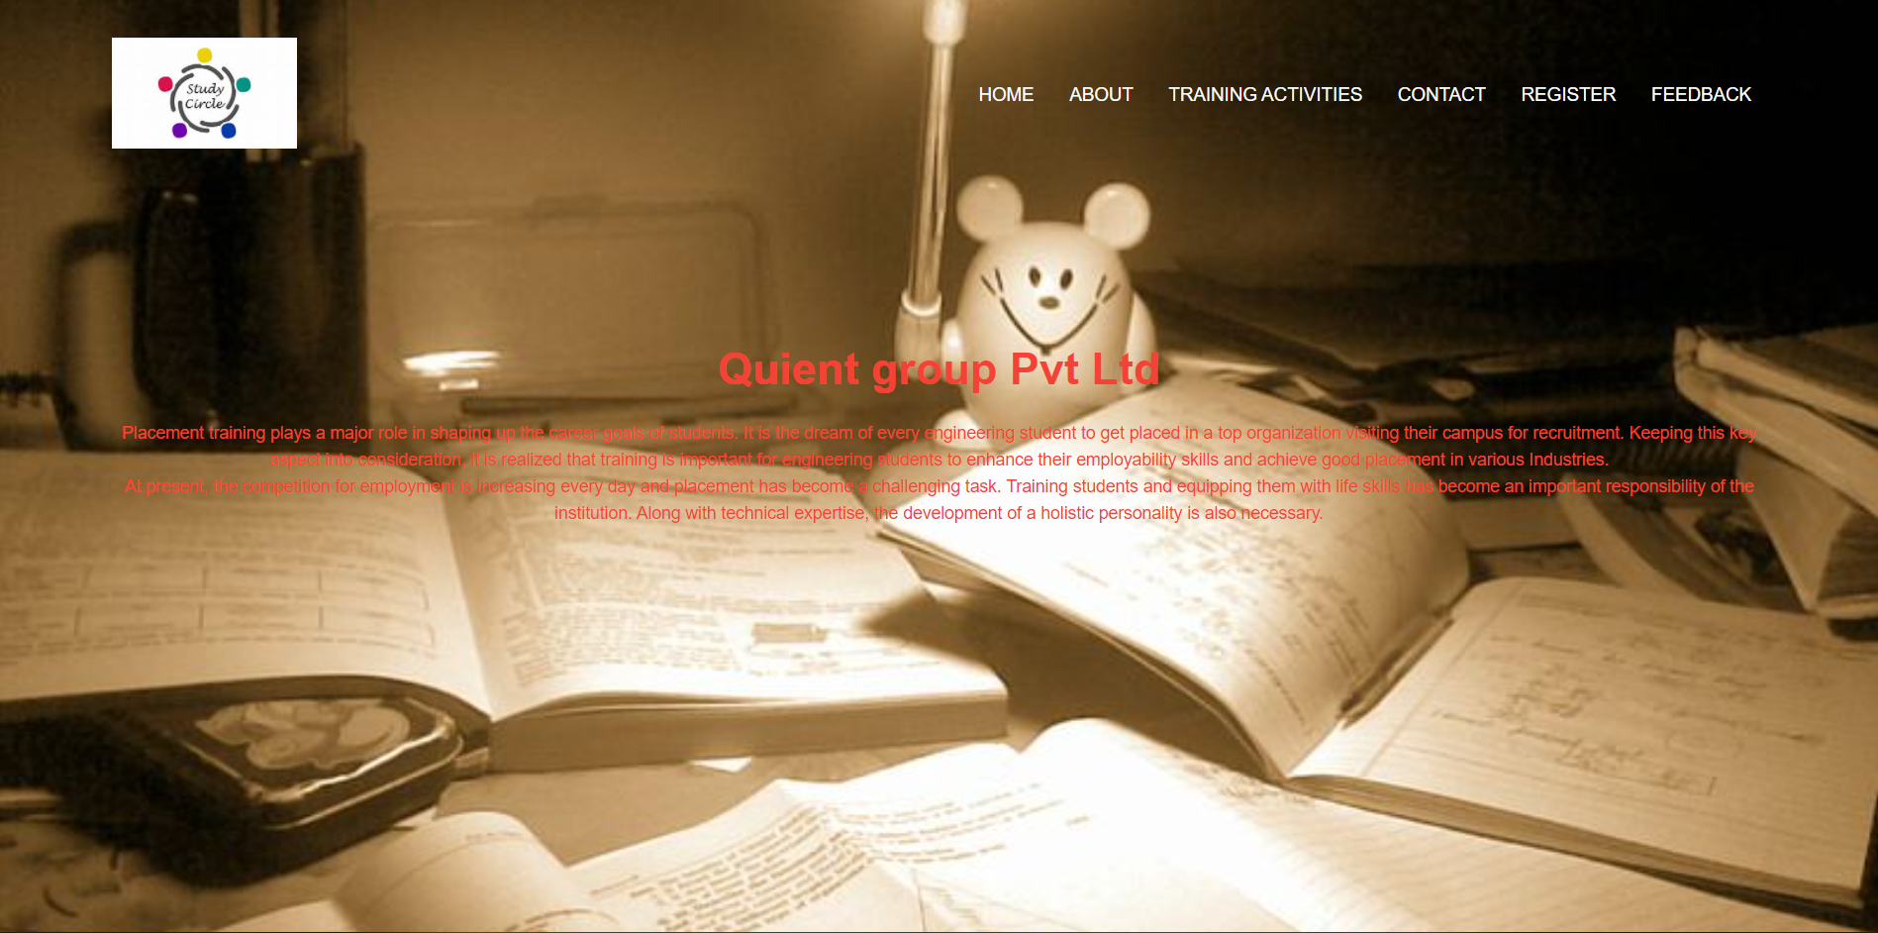

Fig 1: Home page- The company logo,list of

options(HOME,ABOUT,TRAININGACTIVITES,CONTACT,REGISTER,FEEDBACK) and introduction of the company.

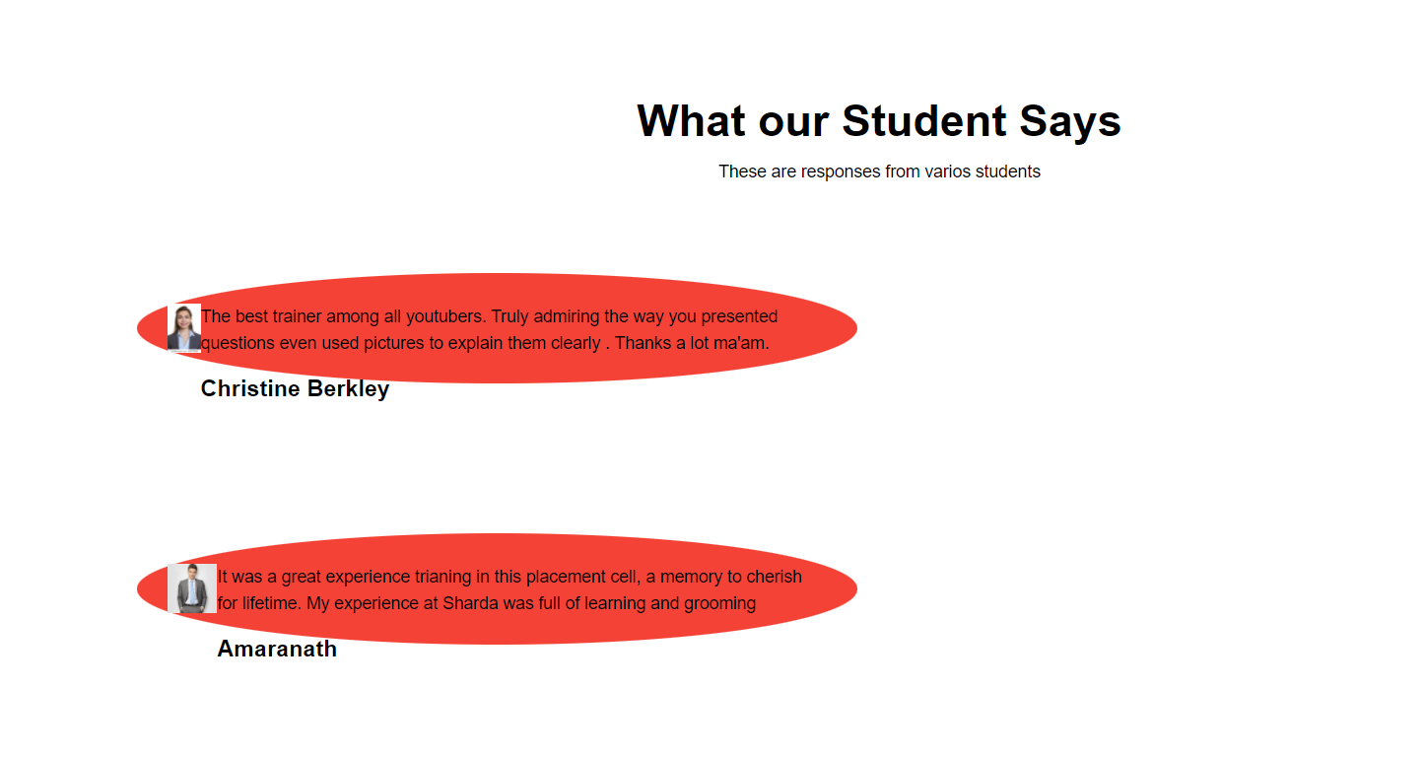

Fig 2: some students feedback – what students says about the placement.

**31**

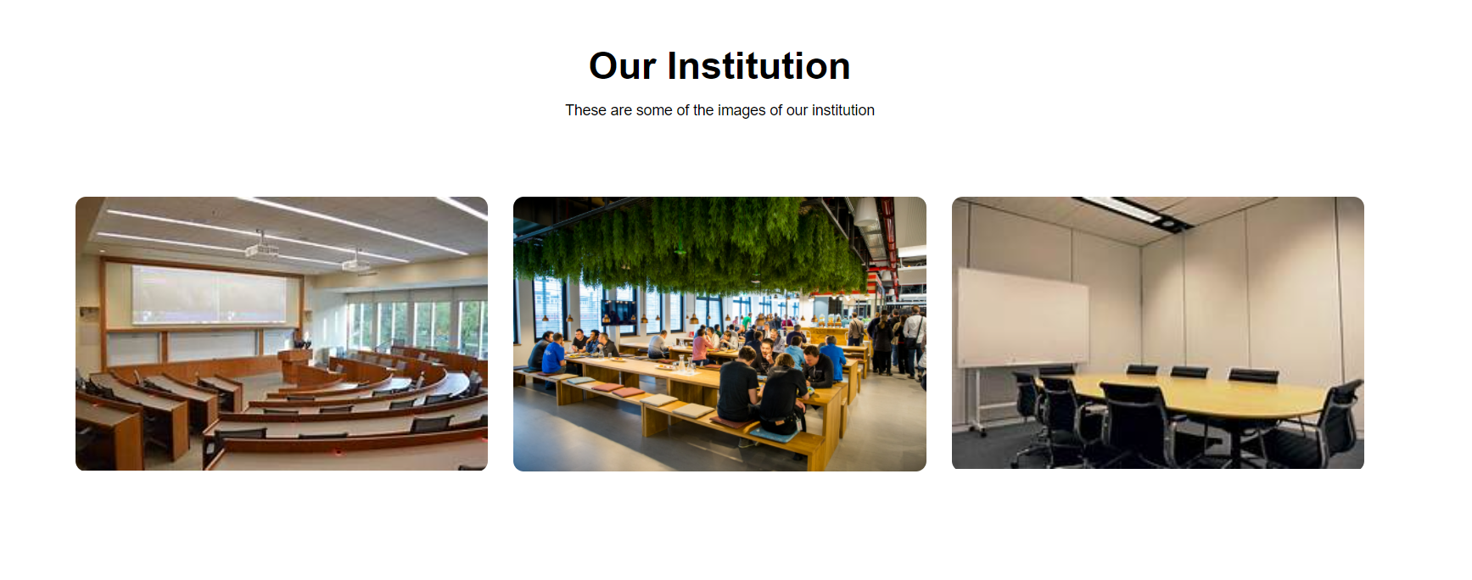

Fig 3: institution images- the environment images like class rooms,cafetaria,discussion platform.

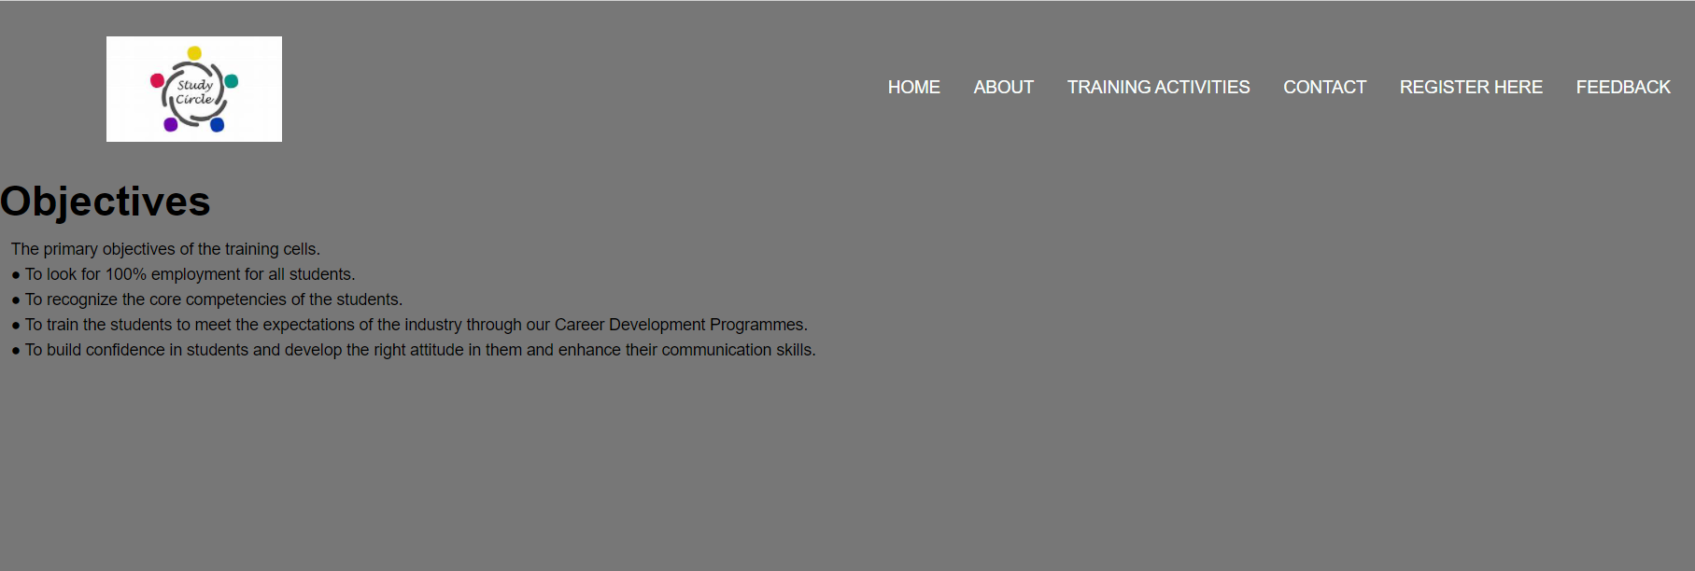

Fig 4: objectives.

32

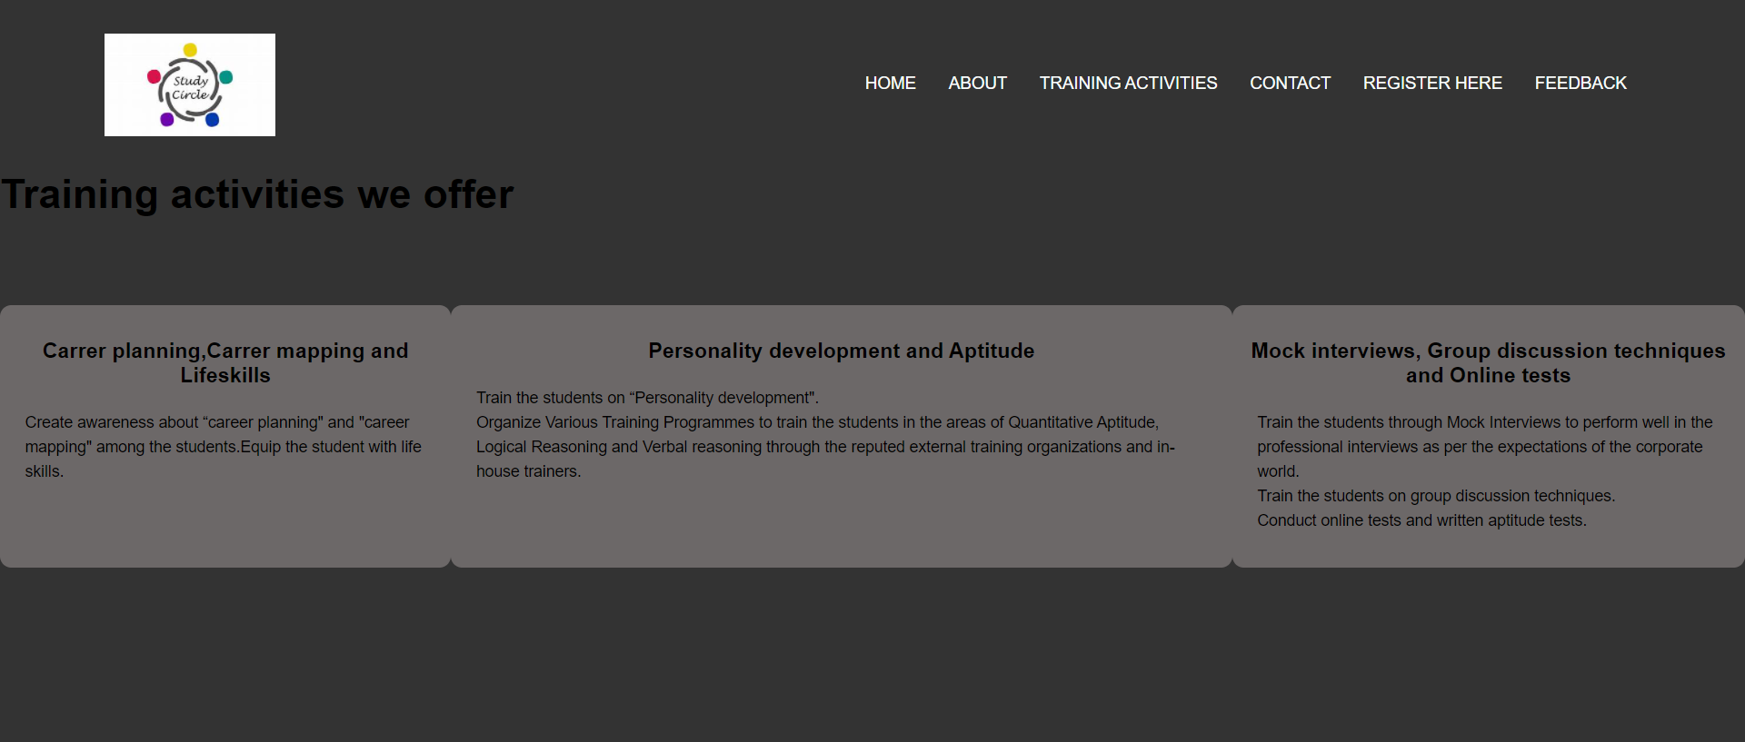

Fig 5 : Training activites list- carrer planning,carrer mapping and lifeskills

-Personality development and aptitude

-Mock interview, group discussion techniques and online tests

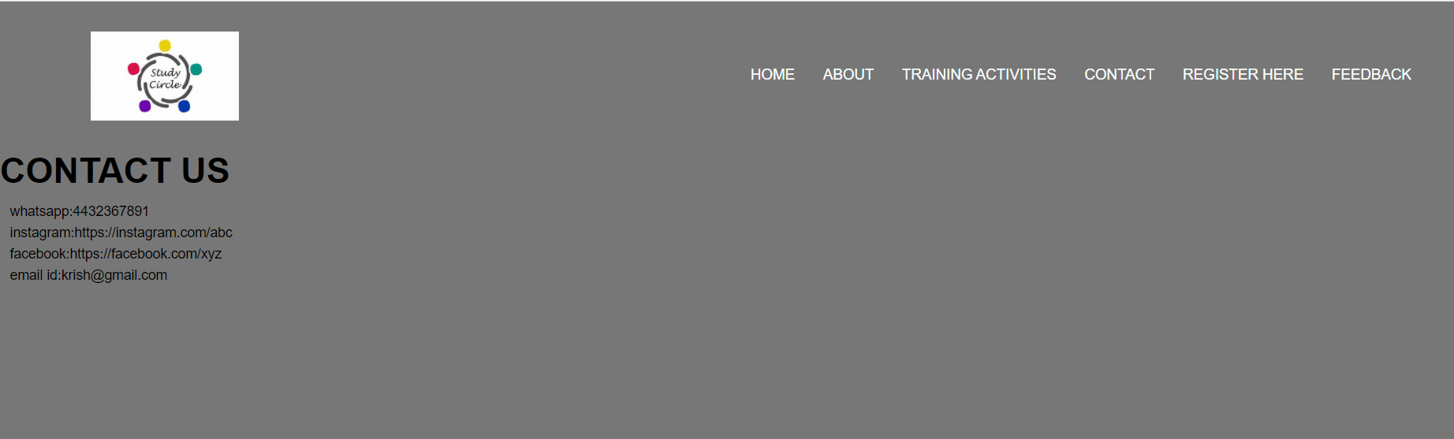

Fig 6: contact us – the details of the company (whatsapp , instagram , facebook, email id)

33



Fig 7 : Register here – It takes the details like frst name, last name, email , Mobile Number and a submit button.

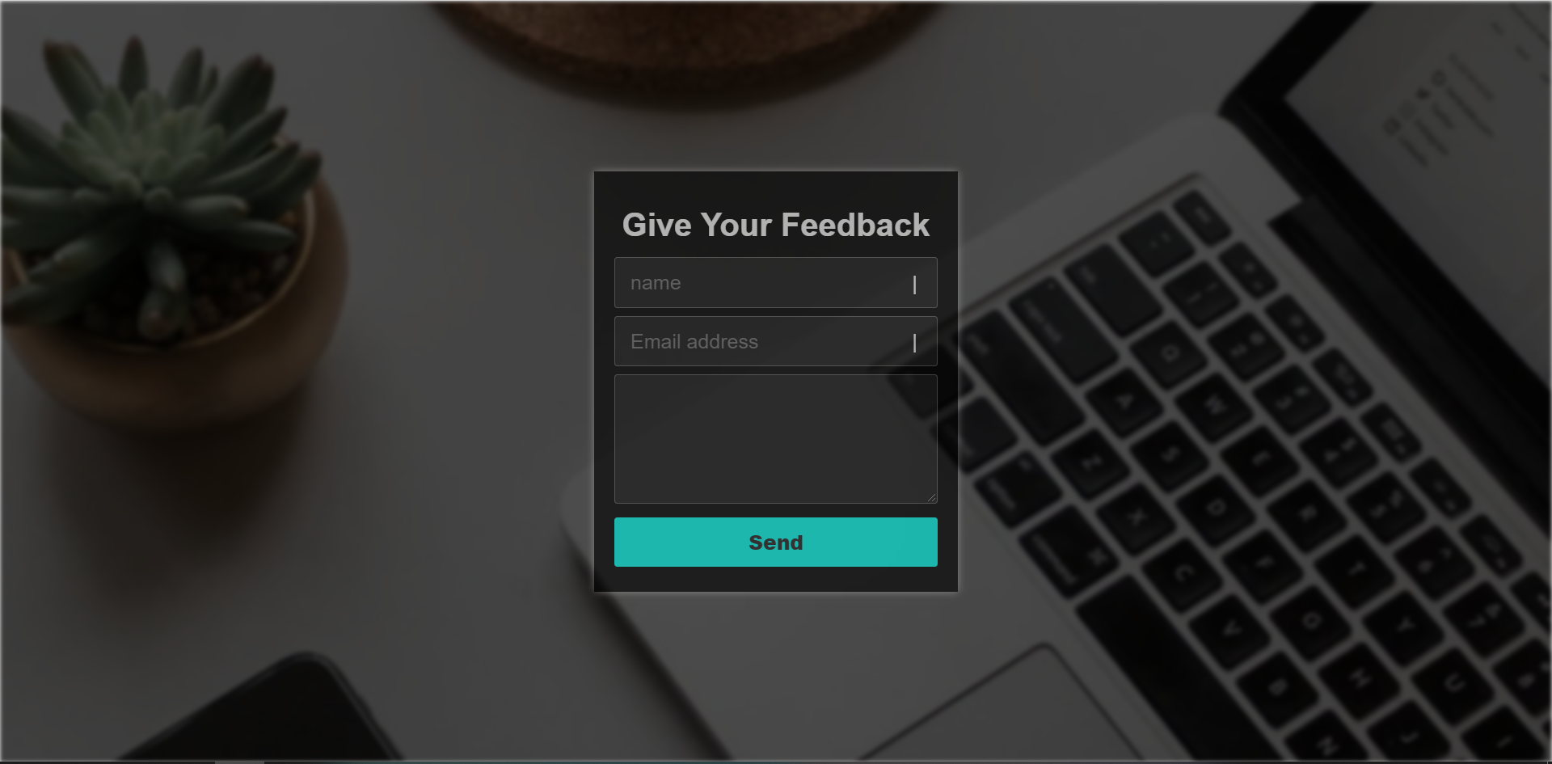

Fig 8 : Give your Feedback – It takes the feedback from students (name, email address, a black space to write the feedback and a send button)

34

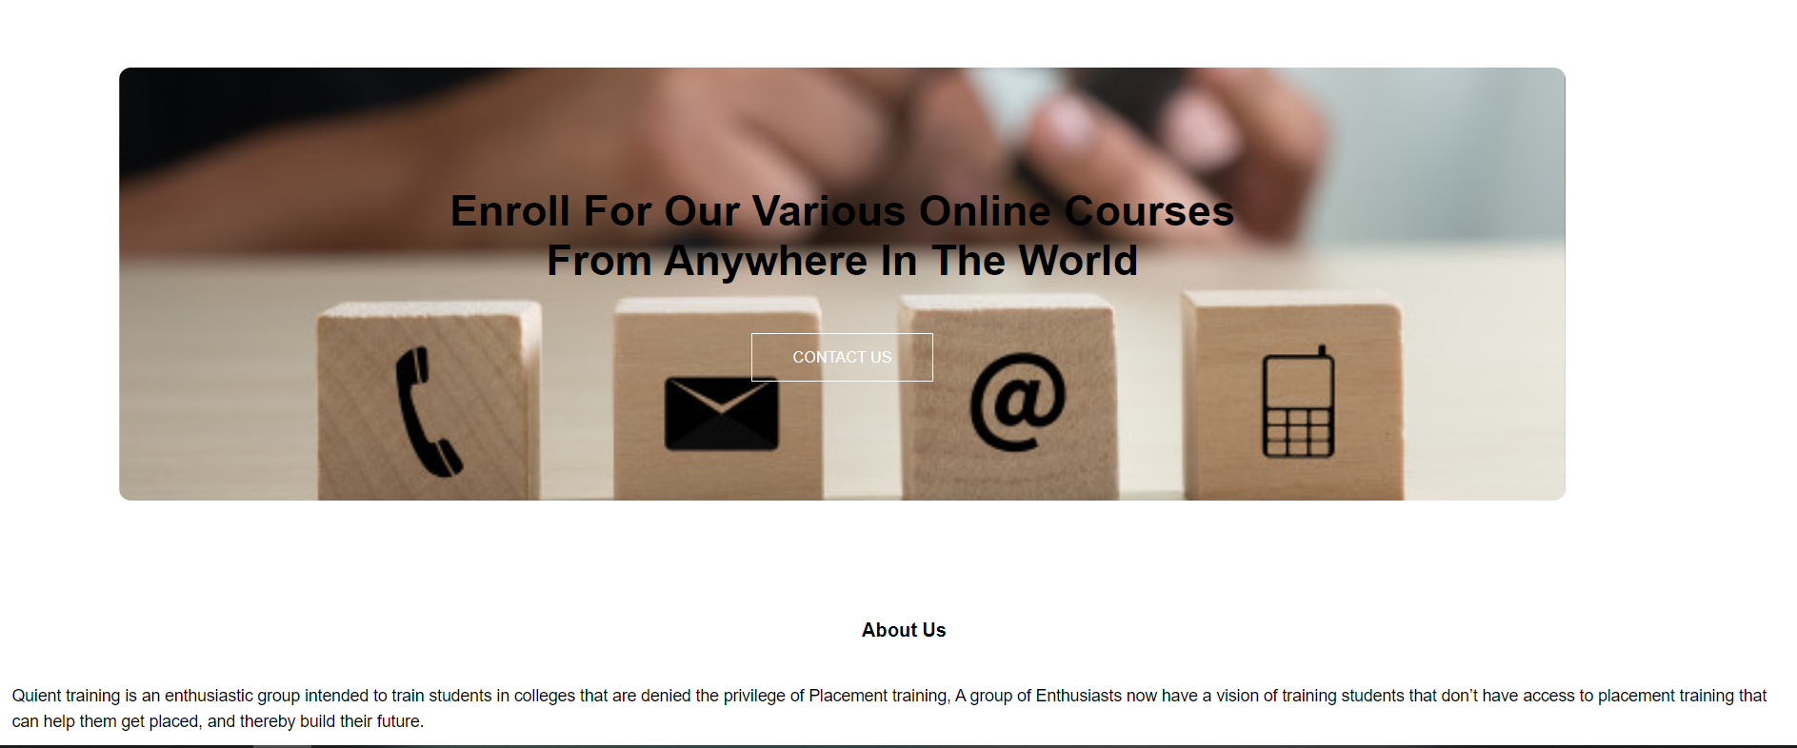

Fig 9: about us

35

**BIBLIOGRAPHY**

* https://[www.w3schools.com](http://www.w3schools.com/)
* https://[www.geeksforgeeks.org](http://www.geeksforgeeks.org/)
* https://freefrontend.com

36